Go to Performance ->SOAM-PM->SOAM Tests

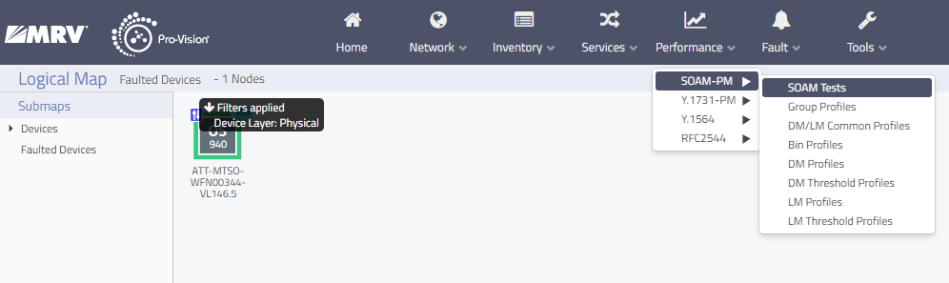

Search for the Test Name. Ex. WFN00360-1673

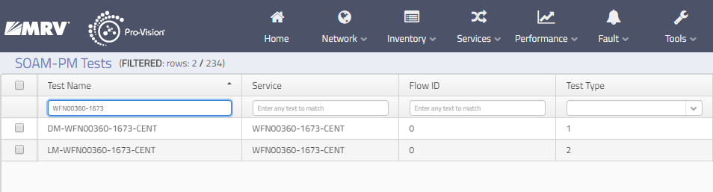

Select and Right-click on Test Type 2 and select SOAM-PM Results (Real Time)

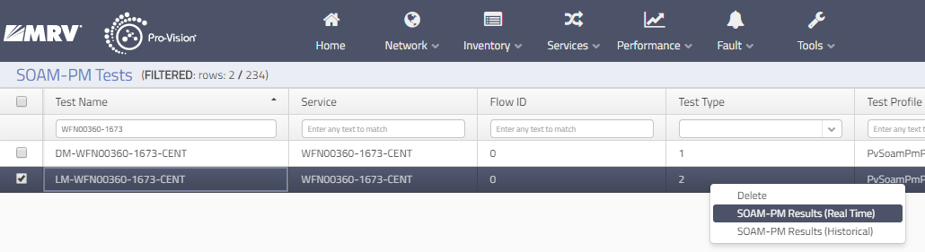

If it’s red, the test needs to be restarted. “Click Close”

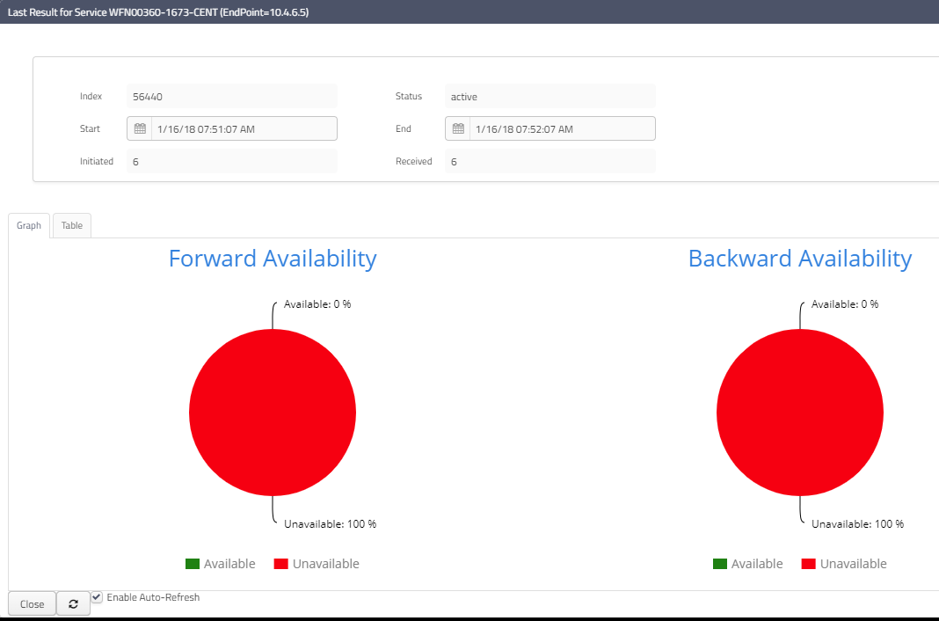

Select and Double click on Test Type 2. Set Enable to “OFF”. Click “Save”.

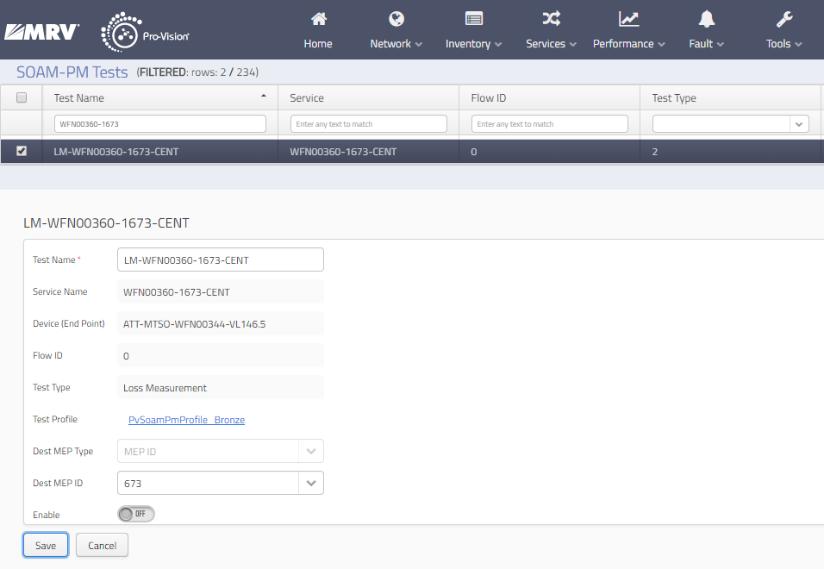

Set Enable back to “ON” and click “Save”

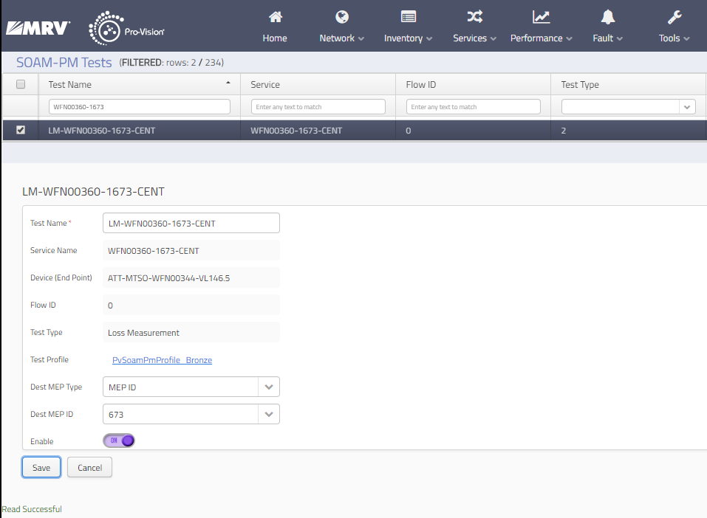

Click “Close” and go back to SOAM-PM Results (Real Time). It will turn green after a bit. Click Refresh if you want to.

