Adding a webpage through filters on Fortinet VDOM
- Log into the VDOM and select the customer
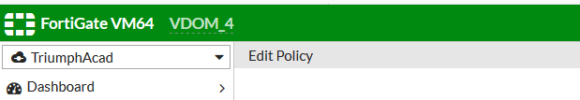
- then select “Policy & Objects” >> “IPv4 Policy”
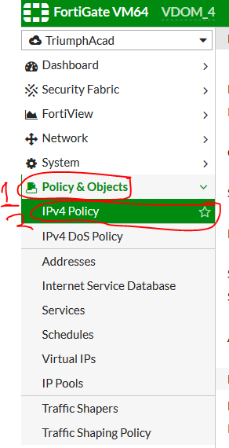
- Select the LAN to WAN that is needing the Policy change, and select Edit at the top of the page.
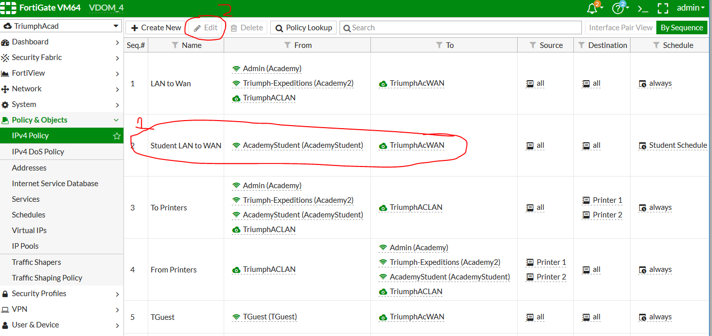
- Select the edit button by the Web Filter
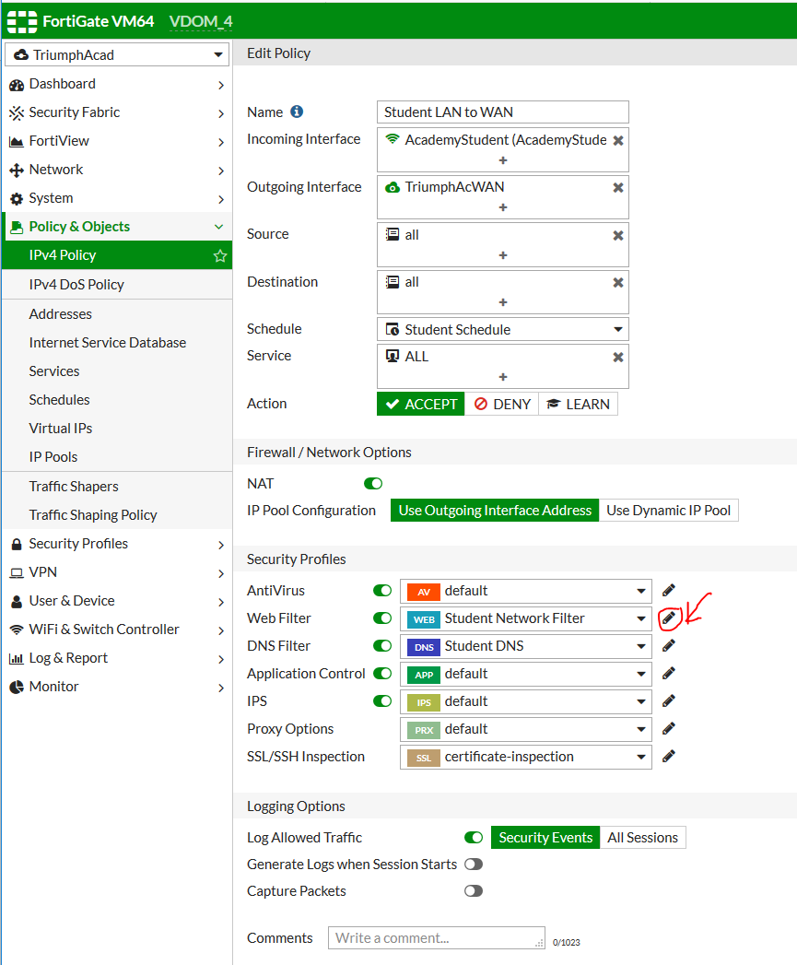
- Under the “Static URL Filter” tab press “+ Create”
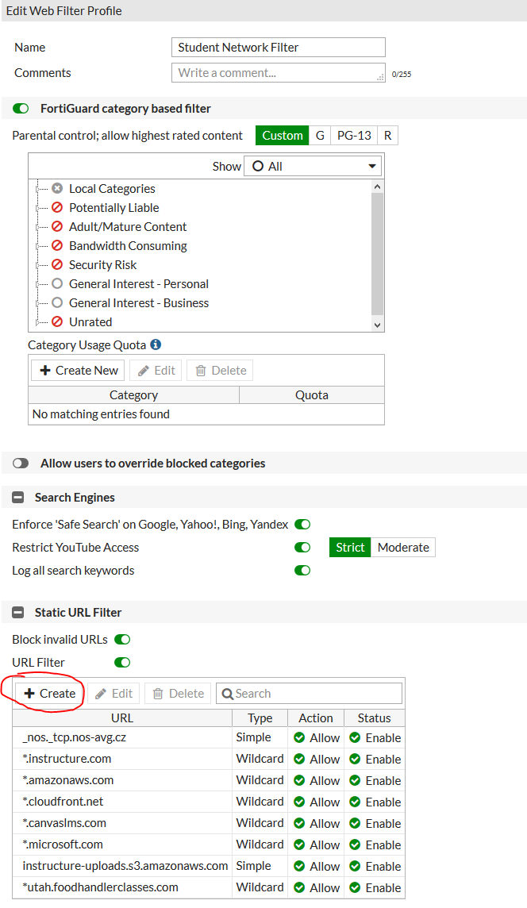
- Enter the 1) URL, 2) Type of URL, and 3) Action, then select “OK”
  - Simple is for exact match. Wildcard is used for all the URLs in the same Domain, and must have an Asterisk before the URL.
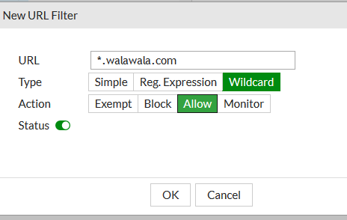
- Use https://fortiguard.com/webfilter to determine the category that the website falls in.
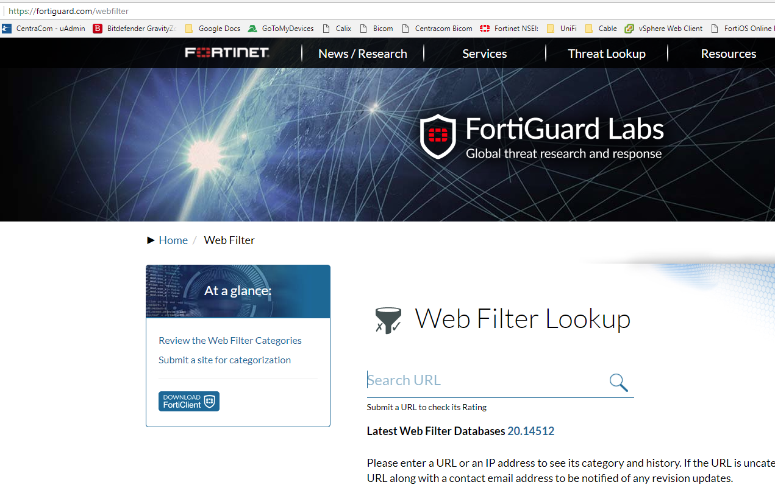
- Find that category, Right click on it, and set to allow.
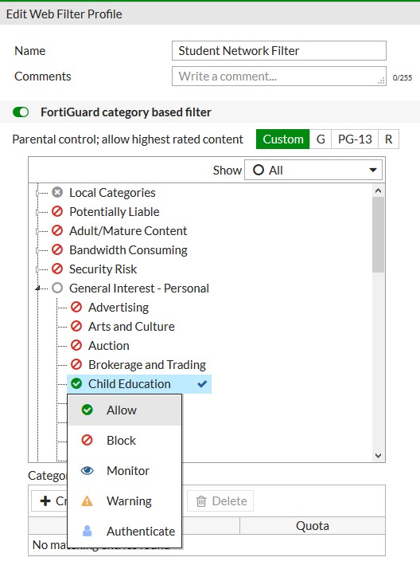
- Select Apply at the bottom of the window.
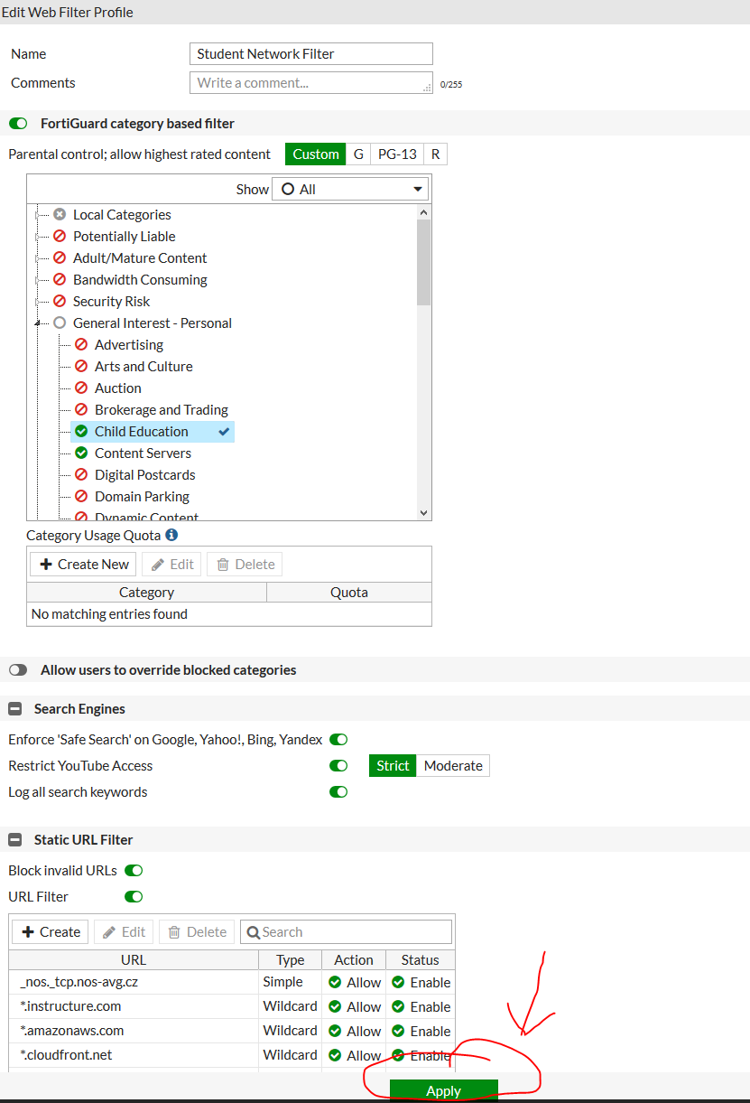
- Select the edit button beside the DNS Filter.
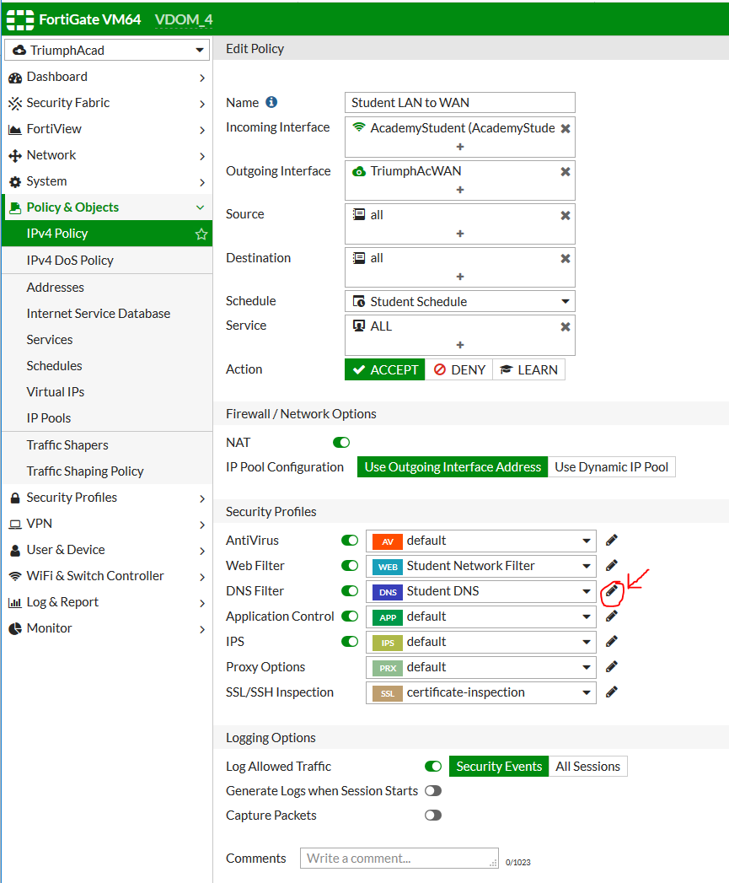
- Repeat steps 5, 6, 8 and 9.

