**Troubleshooting**To trouble shoot you will need to check different areas of truvision. To open an area click on the double square icons indicated. With the exeception of Wifi

Wifi Power Levels

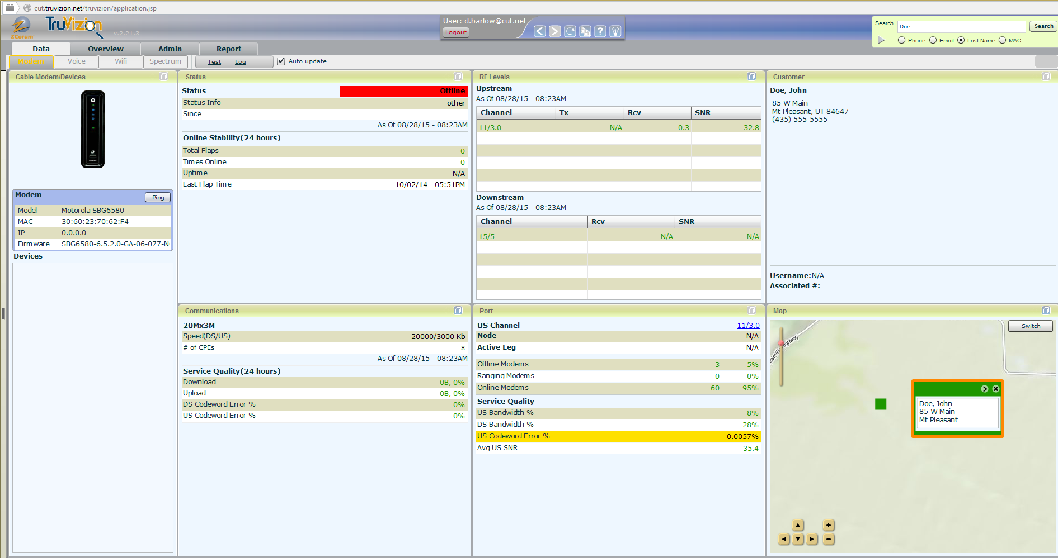

Transfer Rate and Errors

**Check Power Levels**If the Customer is experiencing issue with their internet you can check the power level to see where they are at. Highlighted levels are Yellow (Borderline issue), Red (issue with power level).  
Some fluxuation is normal, the fluxuation in the image below is a variance of 1 or less. If you see a variance greater than 2 you may have an issue. If a customer has reported that they have had issues all week you can change the range to show a 24hrs, 7 days, 30 days, or 90 days, you can even set it to Live and watch it while speaking to them. You can do that here

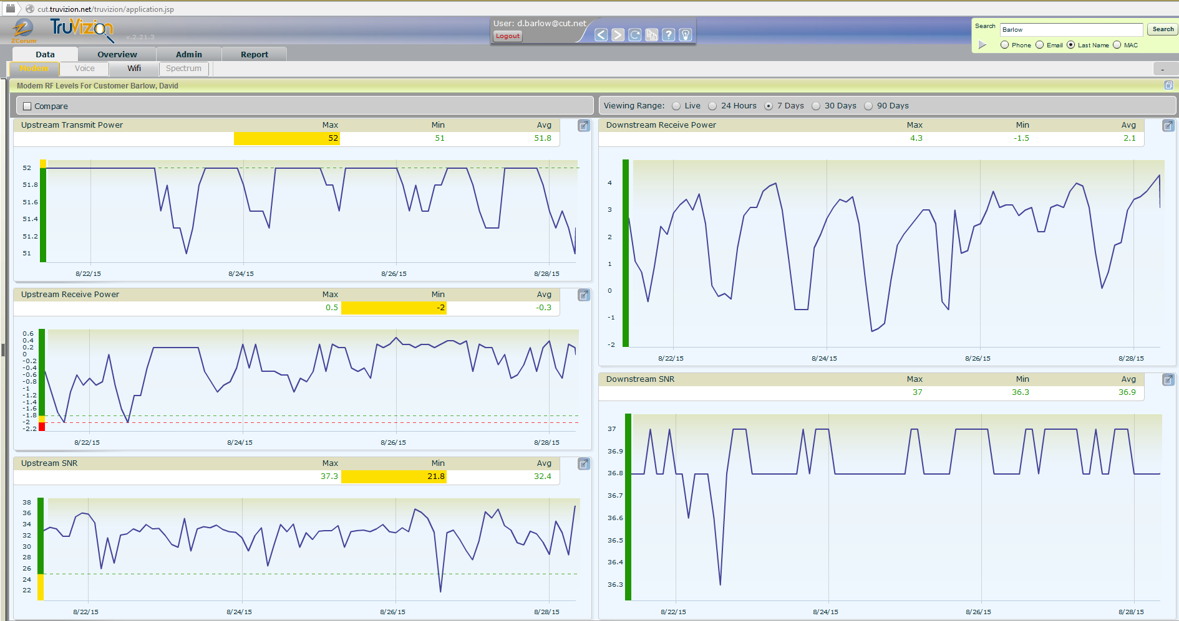

**Check Transfer Rate and Errors**

**Transfer Rate**When viewing the transfer rate keep in mind that if a customer is a gamer, or streams movies (Netflix, Hulu, etc) you will see large spike like those in the image. Any gaps are when the modem has been offline.

**Errors**You will see 2 kinds of errors when looking at this screen. Correctable, and Uncorrectable they are displayed as pink and teal on the graph. Uncorrectable could be cause for an issue where uncorrectable shows the modem fixing the problems without interrupting the customer.

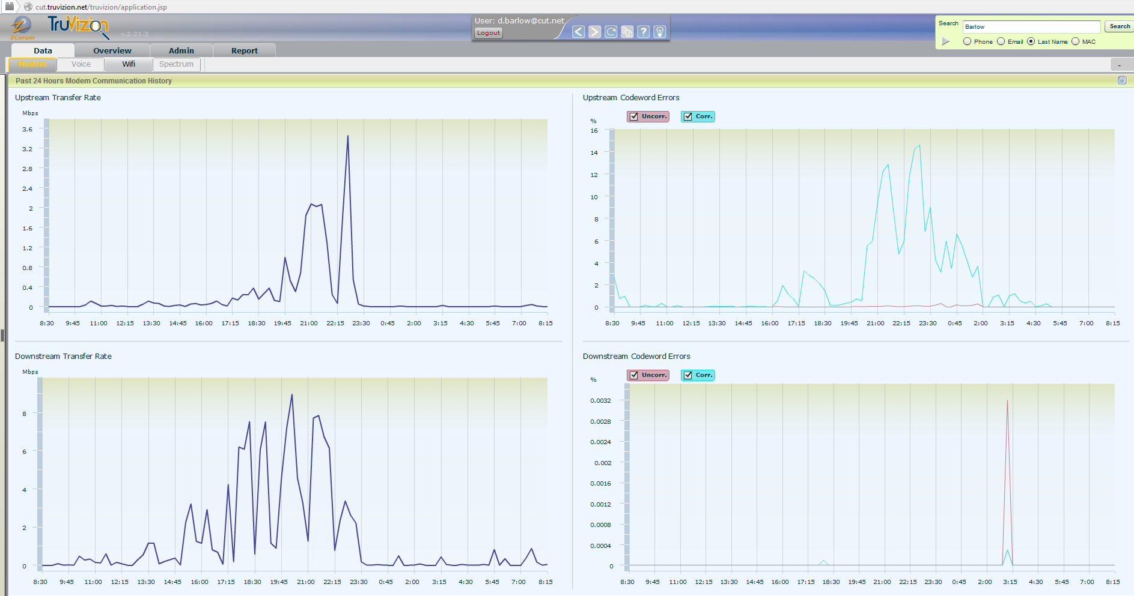

**Wifi**To access the wifi screen (only on some modems) you click on the Wifi tab. This tab will show you information regarding the Wifi, such as: Radio Channel that the Wifi is on, Bandwidth, connected devices, and SSID information. While it does not show the SSID name it will allow you to change the passphrase for the SSID.

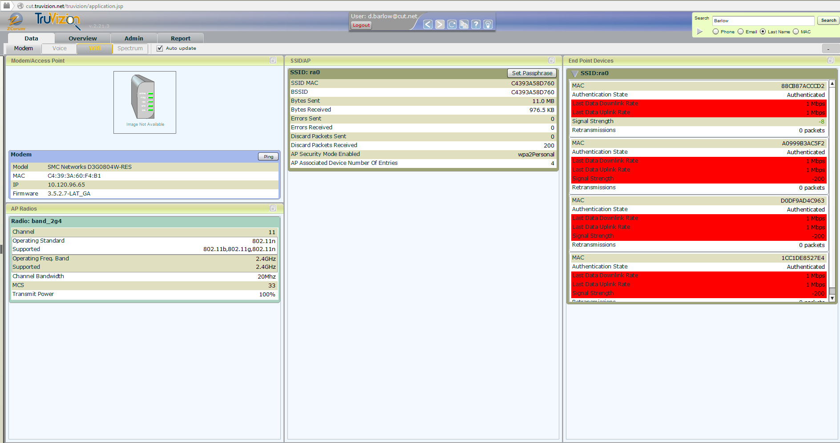

You can also use the Ip Address to log into the modem using the correct login information and change the SSID and Password for the customer.

**Modem Login Information**

Motorola 6580  
Username – admin  
Password - motorola

SMC GN2-GN3  
Username – cusadmin  
Password – password  
or  
Username - mso   
Password - msopassword

SMC D3G804W  
Username - admin   
Password - password

Arris 860  
Username – admin  
Password – password