**Truvision Walkthrough**

Truvision has 7 sections on the main page,   
Cable Modem Device, Status, RF Levels, Customer

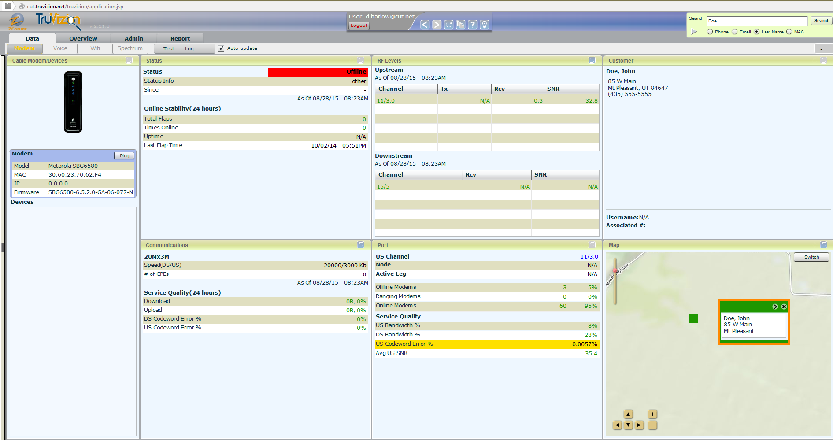

Communications Port Map

Each of these sections will give you information about the service that customer is getting.  
Cable Modem/ Devices: Will give you the Model, MAC Address, IP Address, and Firmware version.  
Status: will tell you whether the modem is Online (green), Offline (red), Or attempting (Yellow). It will   
 also let you know the stability of the connection over the last 24 hours.  
RF Levels: Will give you the Tx, Rcv, SNR levels of the individual channels  
Customer: Will give you the customers information, Name, Address, Phone  
Communications: this will show you the speed package assigned to the modem and will show you the  
 quality of the service over the last 24 hours.  
Port: will show you the channel, Node, Active leg that this modem is connected to  
Map: will show you an approximate location of the modem

**CMTS Selection**

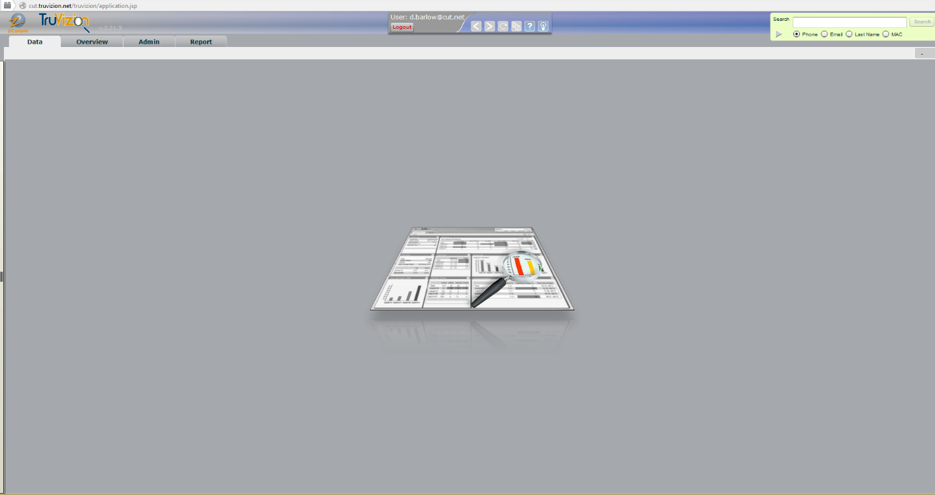

To access the CMTS selection screen you need to click on the dark grey bar on the left of the home screen.

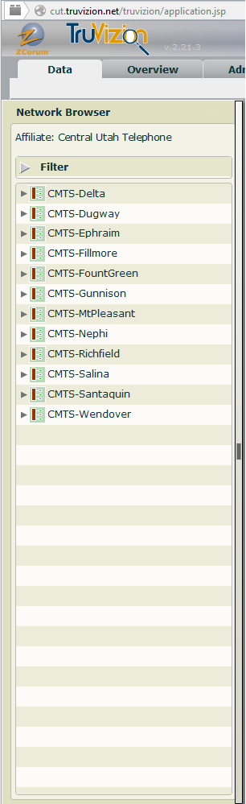Once the CMTS selection window opens you can select the CMTS you wish to view.

**Searching the system**

In the Home page you can search using the basic search bar  
For advanced search options click the grey arrow

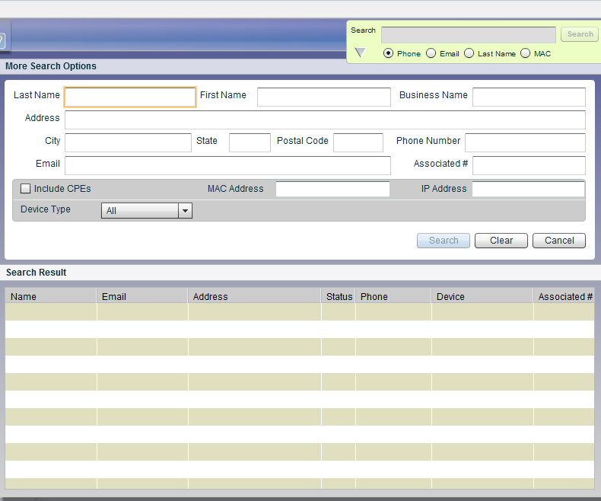

The advanced search will give you the options you need to search by address, IP, MAC, Email, and more