Using putty to SSH into 67.207.47.34  port 2222

Login is root at C3ntrac0msys!

To see status of SIPProt:

Sipprot status - see below

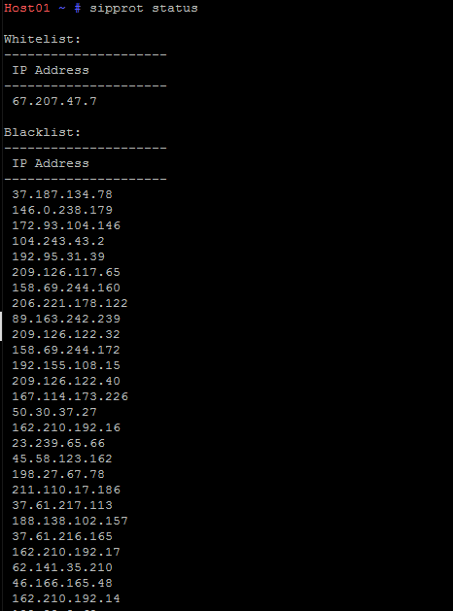

To add to whitelist:

Nano /home/sipprot.whitelist (this will bring up a screen that looks like this)

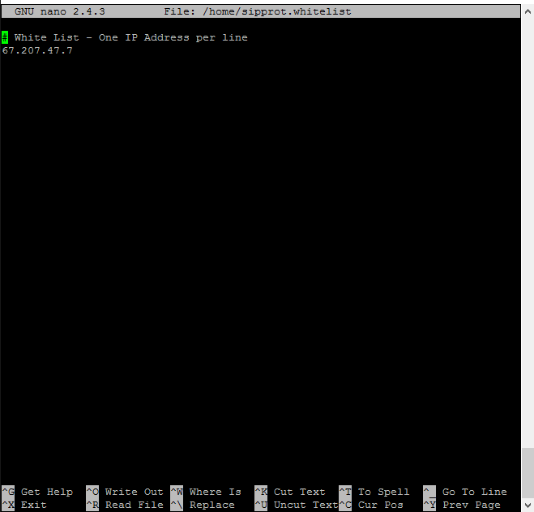

Arrow down below the last IP and add another IP you’d like to whitelist.

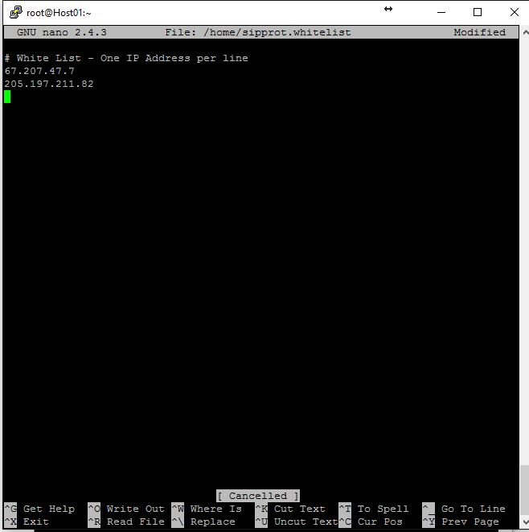

Hit CTRL +X

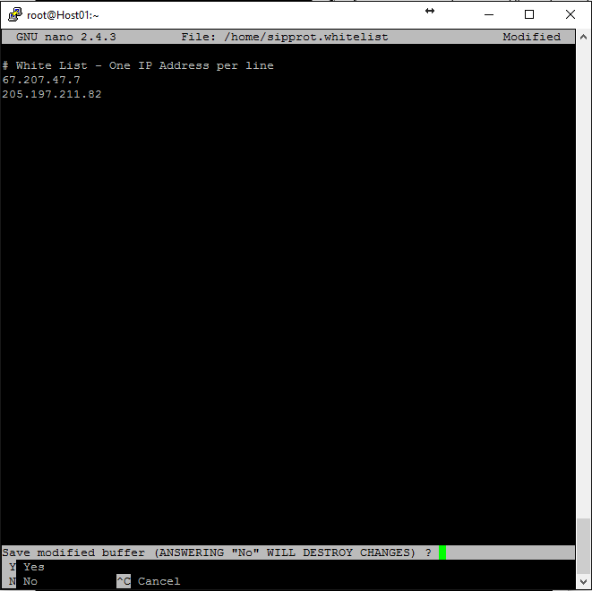

Y – Yes

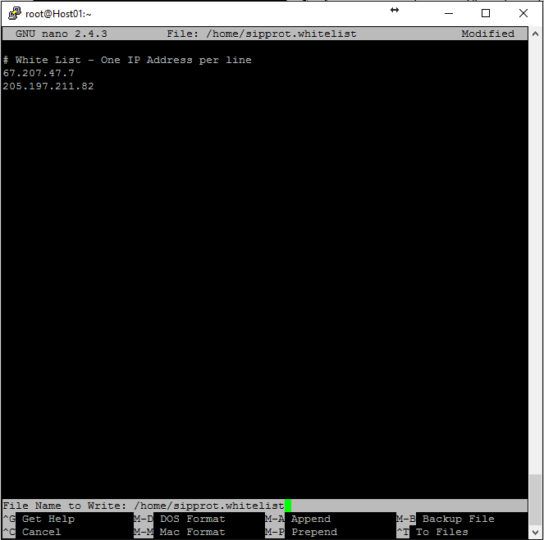

Hit Enter and it will return the original SSH screen.

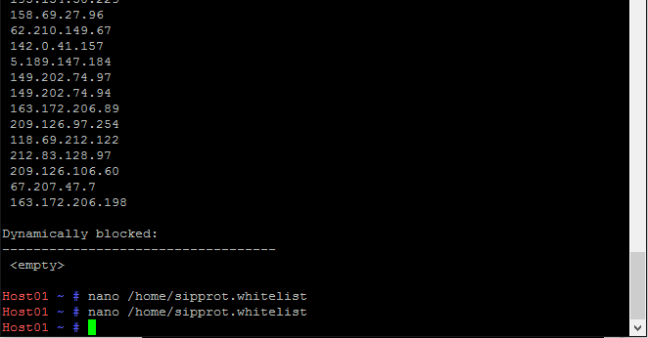

Then stop and restart SIPProt to make sure it takes effect.

